|  |  |
| --- | --- |
| No. of Pages | **3**  B |
| No. of Questions | **3** |

**Department of Computer Science and Engineering**

**MIDTERM EXAMINATION SPRING 2015**

**CSE421: Computer Network**

**Total Marks: 45 Time Allowed: 55 minutes**



* Answer ALL **THREE (3)** questions
* Figure in bracket [] next to each question indicates marks for that question



**Question 1**

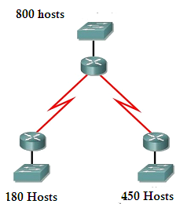

**Figure no. 1**

1. Suppose a company is given a block **210.96.160.0/21.** But you need three more sub networks for your organization and two more for the WAN Link as shown in figure no. 1. Show how you can have 5 more subnets out of the original network address as per host requirements. Do not forget to show basic calculations. [7.5 marks]
2. What is a stub network? And what type of routes do we configure for stub networks and why? [4 marks]
3. The **show ip route** command gives the following output shown in figure no. 2.

**C 192.168.2.0/24 is directly connected, Ethernet0/0**

**C 192.168.5.0/24 is directly connected, Serial0/0**

**C 192.168.1.0/24 is directly connected, Serial0/1**

**R 192.168.3.0/24 [120/1] via 192.168.5.1, 00:00:03, Serial0/0**

**R 192.168.6.0/24 [120/2] via 192.168.5.1, 00:00:12, Serial 0/0**

**S 192.168.4.0/24 [1/0] via 192.168.2.1**

**Figure no. 2**

**Figure no. 2**

The router will drop a packet destined for 200.168.4.7/24, why? How can we avoid dropping the packet? [3.5 marks]

**Question 2**

1. Distance vector routing protocols is asynchronous, why? [3 marks]
2. The router below is running RIPv2 shown in figure no. 3. Summarize the following networks shown at the router so that it can advertise only one summarized network in its updates instead of the 8 separate networks. Show calculations. [4 marks]

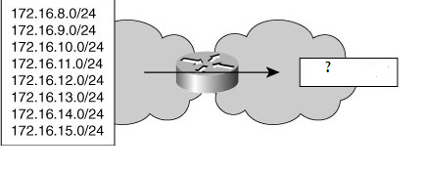

**Figure no. 3**

1. How do routers use count to infinity to avoid loops? [4 marks]
2. Explain the two terms circled in the output in figure no. 4 below. [4 marks]

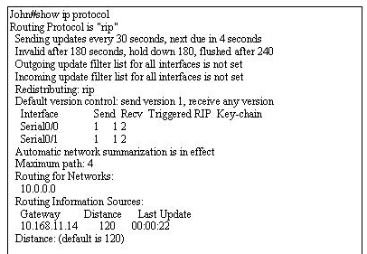

**Figure no. 4**

**Question 3**

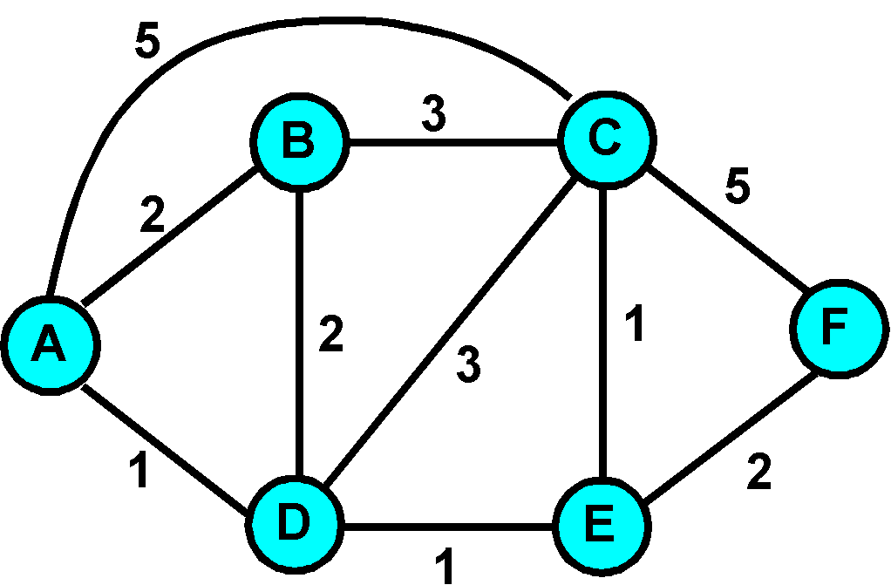

**Figure no. 5**

1. Link state routing protocol uses Dijkstra’s algorithm. Now using Dijkstra’s algorithm, compute the shortest path from Fto all other remote networks shown in figure no.5. Use the table provided. [5 marks]

C

B

A



FastEthernet

LAN C

128 Kbps

E1 (2.048Mbps)

**Figure no. 6**

1. By default, cost is calculated as 108/bandwidth in ospf. What cost would router A calculate to a destination on LAN C shown in figure no. 6? [3 marks]
2. When does OSPF routing protocol send in query packets? [3 marks]

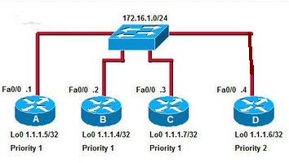

**Figure no. 7**

1. In the above figure no.7, all routers are running ospf routing protocol. In the above scenario which routers are selected as the DR and BDR? Explain why? [4 marks]

**Figure no. 7**

**THE END**